DATS 6103

Individual Final Report

May 1, 2021

Bradley Reardon

1. **Introduction**

* The 2020 US Presidential Election caused a great deal of speculation surrounding voter-turnout, largely driven by the high-profile candidates and new voting methods enacted to account for Covid-19 safety precautions. Furthermore, there is a long-standing interest in what drives eligible voters to either vote or not vote, and who to vote for if a vote is cast. We decided to dive deeper into the latter and explore which characteristics and features of a voter drove them to choose between Donald Trump and Joe Biden in the 2020 US Presidential Election.
* In this project, we trained and tested variations of both random forest and gradient boosting classifiers using survey data compiled by Ipsos, a multinational market research and consulting firm, and FiveThirtyEight, an American website that focuses on opinion poll analysis, politics, economics, and sports blogging. Our goal was to accurately predict the answer a survey taker might choose for question 23, “Which presidential candidate are you planning to support?”
* The shared work consisted of deciding on a dataset and project idea, cleaning of the dataset, exploratory data analysis, preprocessing, modeling, model comparison, GUI development, creating a powerpoint presentation, writing the group report, and creating a demo of the GUI.

1. **Personal Contribution**

* **Code:**
  + Preprocessing
    - Added new column, “Age_Group” in order to create a pie chart showing the distribution by age group.
    - Split data into train and test sets.
  + EDA
    - Created pie charts and histograms to check for normality in our demographic features.
    - Calculated and plotted feature importance
  + Modeling
    - Trained and tested the full models for both the random forest and gradient boosting classifiers as well as the gradient boosting slim model.
    - Tested and compared the models to see which model performed the best.
  + Merging of Code
    - Provided the initial merge of our code into a single final python file. Divya and I then both touched up the file until it was finalized.
* **Powerpoint:**
  + Found the powerpoint template.
  + Formatted powerepoint and added initial information as draft 1.
    - Touched up powerpoint with other group members to finalize the presentation.
  + Added audio recording to my section of the presentation.
* **Group Final Report:**
  + Wrote first draft
    - Finalized rest of report with group members.

1. **Personal Contribution in Detail**

* Please see the diagrams in the results section along with the code appended at the end of the report.

1. **Results**

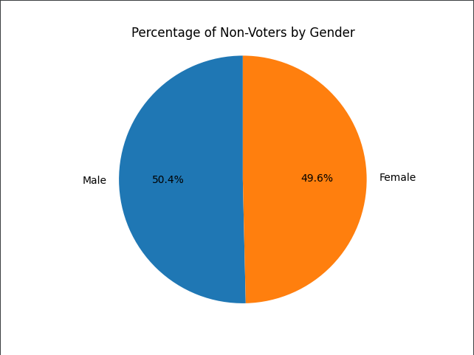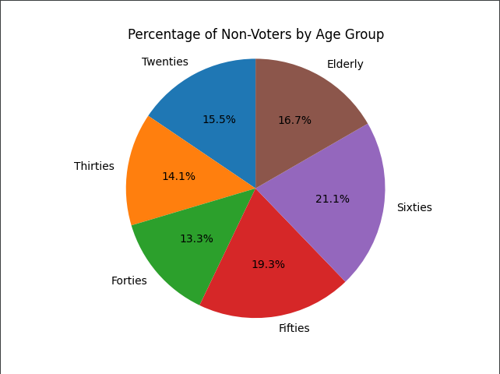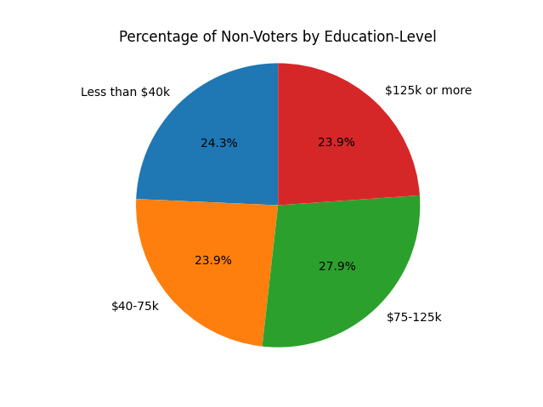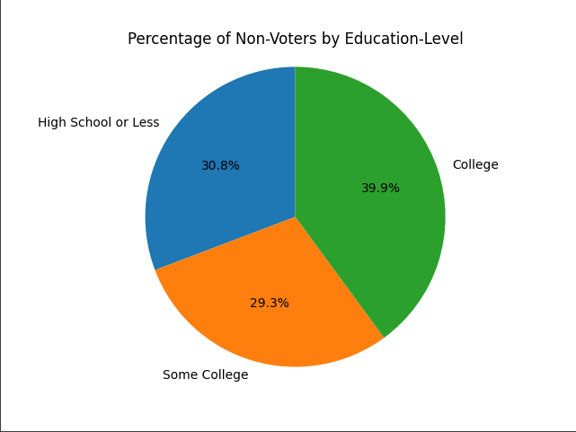

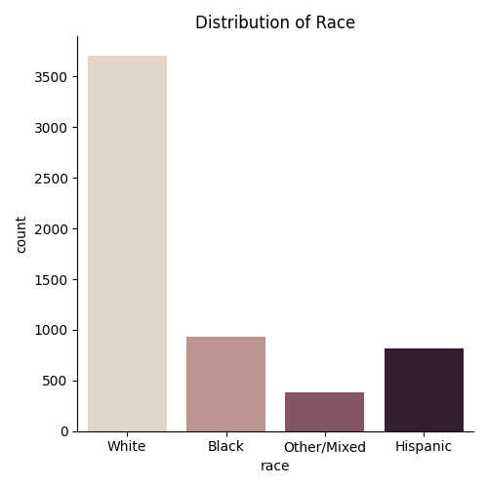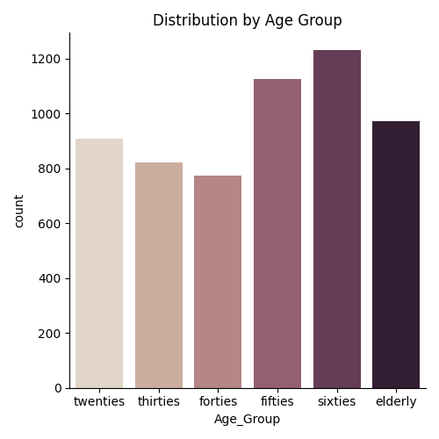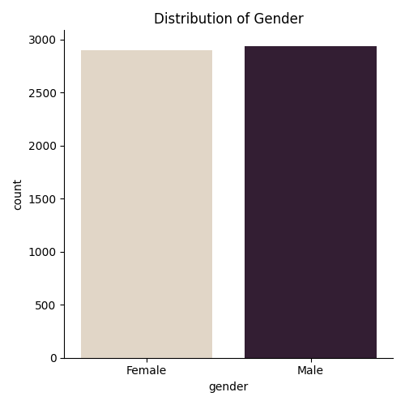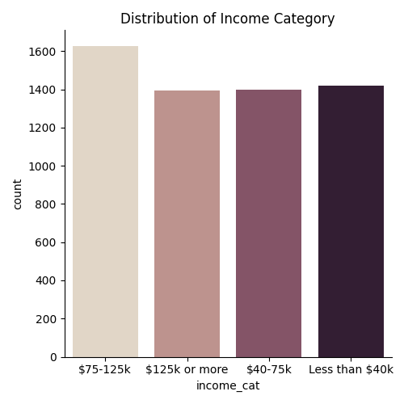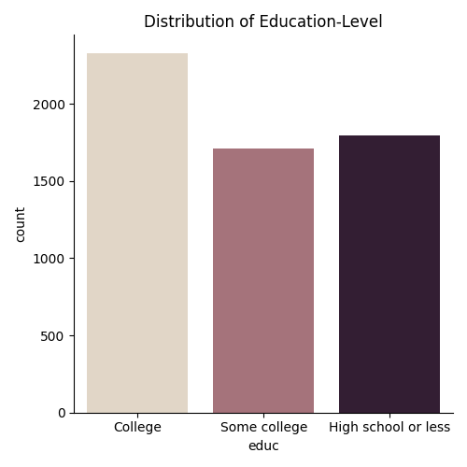

|  |  |  |  |
| --- | --- | --- | --- |
| **Model 1**  **Random Forest - Full Model** | **Model 2**  **Random Forest - Slim Model** | **Model 3**  **Gradient Boosting - Full Model** | **Model 4**  **Gradient Boosting - Slim Model** |
| F1-score: 0.98  Accuracy score: 0.97 | F1-score: 0.93  Accuracy score: 0.93 | F1-score: 0.97  Accuracy score: 0.97 | F1-score: 0.50  Accuracy score: 0.51 |

1. **Summary**
   * Using FiveThirtyEight survey data, we decided to predict who voters would vote for president based on their survey answers
   * We conducted exploratory data analysis to better understand the group of voters and make sure the classes were balanced
   * We preprocessed our data - label encoding, dropping columns and observations
   * We fit both random forest and gradient boosting models, and we ran on “full” and “slim” feature sets
   * We saw extremely high accuracy and f1 scores
   * Random forest did better than gradient boosting, and “full” feature models did better than “slim” feature models
2. **Percent of Code**
   * 0%. No code was copied from any external sources. Syntax and functions were referenced from official python package sites, but we wrote all code on our own.
3. **References**

* <https://scikit-learn.org>
* <https://numpy.org/>
* <https://pandas.pydata.org/>
* <https://pypi.org/project/PyQt5/>
* <https://medium.com/analytics-vidhya/evaluating-a-random-forest-model-9d165595ad56>
* <https://www.datasciencecentral.com/profiles/blogs/decision-tree-vs-random-forest-vs-boosted-trees-explained#:~:text=Like%20random%20forests%2C%20gradient%20boosting,one%20tree%20at%20a%20time>
* <https://morningconsult.com/opinions/to-persuade-or-to-turn-out-voters-is-that-the-question/>
* https://www.bloomberg.com/graphics/2020-us-election-results/methodology

**Appended Code – My Personal Code**

#------------------------------------------------------  
# Import necessary packages  
#------------------------------------------------------  
  
import numpy as np  
import pandas as pd  
import matplotlib.pyplot as plt  
import seaborn as sns  
from sklearn.model_selection import train_test_split  
from sklearn.model_selection import cross_validate  
from sklearn.preprocessing import LabelEncoder  
from sklearn.ensemble import RandomForestClassifier  
from sklearn.feature_selection import SelectFromModel  
import seaborn as sns  
from sklearn.metrics import confusion_matrix  
from sklearn.metrics import accuracy_score  
from sklearn.metrics import classification_report  
from sklearn.metrics import roc_auc_score  
from sklearn.ensemble import GradientBoostingClassifier  
  
#------------------------------------------------------  
# Read in csv file  
#------------------------------------------------------  
  
nv_df = pd.read_csv('nonvoters_data.csv')  
# print(nv_df.shape)  
# print(nv_df.columns)  
print(nv_df.shape)  
#------------------------------------------------------  
# Preprocessing  
#------------------------------------------------------  
  
nv_df.columns = ['RespId', 'weight',  
 'q1_uscitizen',  
 'q2_important_voting','q2_important_jury','q2_important_following','q2_important_displaying','q2_important_census',  
 'q2_important_pledge','q2_important_military','q2_important_respect','q2_important_god','q2_important_protesting',  
 'q3_statement_racism1`','q3_statement_racism2','q3_statement_feminine',  
 'q3_statement_msm','q3_statement_politiciansdontcare','q3_statement_besensitive',  
 'q4_impact_officialsfed','q4_impact_officialsstate','q4_impact_officialslocal',  
 'q4_impact_news','q4_impact_wallstreet','q4_impact_lawenforcement',  
 'q5_electionmatters',  
 'q6_officialsarelikeyou',  
 'q7_governmentdesign',  
 'q8_trust_presidency','q8_trust_congress','q8_trust_supremecourt','q8_trust_cdc','q8_trust_electedofficials',  
 'q8_trust_fbicia','q8_trust_newsmedia','q8_trust_police','q8_trust_postalservice',  
 'q9_politicalsystems_democracy','q9_politicalsystems_experts','q9_politicalsystems_strongleader','q9_politicalsystems_army',  
 'q10_disability','q10_chronic_illness','q10_unemployed','q10_evicted',  
 'q11_lostjob','q11_gotcovid','q11_familycovid',  
 'q11_coviddeath','q11_worriedmoney','q11_quitjob',  
 'q14_view_of_republicans',  
 'q15_view_of_democrats',  
 'q16_how_easy_vote',  
 'q17_secure_votingmachines','q17_secure_paperballotsinperson','q17_secure_paperballotsmail','q17_secure_electronicvotesonline',  
 'q18_votingsituations1','q18_votingsituations2','q18_votingsituations3','q18_votingsituations4','q18_votingsituations5',  
 'q18_votingsituations6','q18_votingsituations7','q18_votingsituations8','q18_votingsituations9','q18_votingsituations10',  
 'q19_get_more_voting1','q19_get_more_voting2','q19_get_more_voting3','q19_get_more_voting4','q19_get_more_voting5',  
 'q19_get_more_voting6','q19_get_more_voting7','q19_get_more_voting8','q19_get_more_voting9','q19_get_more_voting10',  
 'q20_currentlyregistered',  
 'q21_plan_to_vote',  
 'q22_whynotvoting_2020',  
 'q23_which_candidate_supporting',  
 'q24_preferred_voting_method',  
 'q25_howcloselyfollowing_election',  
 'q26_which_voting_category',  
 'q27_didyouvotein18','q27_didyouvotein16','q27_didyouvotein14',  
 'q27_didyouvotein12','q27_didyouvotein10','q27_didyouvotein08',  
 'q28_whydidyouvote_past1','q28_whydidyouvote_past2','q28_whydidyouvote_past3','q28_whydidyouvote_past4',  
 'q28_whydidyouvote_past5','q28_whydidyouvote_past6','q28_whydidyouvote_past7','q28_whydidyouvote_past8',  
 'q29_whydidyounotvote_past1','q29_whydidyounotvote_past2','q29_whydidyounotvote_past3','q29_whydidyounotvote_past4','q29_whydidyounotvote_past5',  
 'q29_whydidyounotvote_past6','q29_whydidyounotvote_past7','q29_whydidyounotvote_past8','q29_whydidyounotvote_past9','q29_whydidyounotvote_past10',  
 'q30_partyidentification',  
 'q31_republicantype',  
 'q32_democratictype',  
 'q33_closertowhichparty',  
 'ppage', 'educ', 'race', 'gender', 'income_cat', 'voter_category'  
 ]  
  
nv_df.drop(['q1_uscitizen','q22_whynotvoting_2020',  
 'q28_whydidyouvote_past1','q28_whydidyouvote_past2','q28_whydidyouvote_past3','q28_whydidyouvote_past4',  
 'q28_whydidyouvote_past5','q28_whydidyouvote_past6','q28_whydidyouvote_past7','q28_whydidyouvote_past8',  
 'q29_whydidyounotvote_past1','q29_whydidyounotvote_past2','q29_whydidyounotvote_past3','q29_whydidyounotvote_past4','q29_whydidyounotvote_past5',  
 'q29_whydidyounotvote_past6','q29_whydidyounotvote_past7','q29_whydidyounotvote_past8','q29_whydidyounotvote_past9','q29_whydidyounotvote_past10',  
 'q31_republicantype',  
 'q32_democratictype',  
 'q33_closertowhichparty',  
 'RespId',  
 'weight'  
 ], axis=1, inplace=True)  
  
age_labels_cut = ['twenties', 'thirties', 'forties', 'fifties', 'sixties', 'elderly']  
age_bins= [20, 30, 40, 50, 60, 70, 200]  
nv_df['Age_Group'] = pd.cut(nv_df['ppage'], bins = age_bins, labels = age_labels_cut, right = False)  
  
  
# %%-----------------------------------------------------------------------  
# Race Pie Chart & Histogram  
  
  
distinct_races = set(nv_df['race'])  
total_race = nv_df['race'].count()  
hispanic_percentage = nv_df[nv_df['race'] == 'Hispanic']['race'].count()/total_race  
other_mixed_percentage = nv_df[nv_df['race'] == 'Other/Mixed']['race'].count()/total_race  
white_percentage = nv_df[nv_df['race'] == 'White']['race'].count()/total_race  
black_percentage = nv_df[nv_df['race'] == 'Black']['race'].count()/total_race  
race_percentages = [white_percentage, black_percentage, hispanic_percentage, other_mixed_percentage]  
race_labels = ['White', 'Black', 'Hispanic', 'Other/Mixed']  
  
race_pie, ax1 = plt.subplots()  
ax1.pie(race_percentages, labels=race_labels, autopct='%1.1f%%', startangle=90)  
ax1.axis('equal') # Equal aspect ratio ensures that pie is drawn as a circle.  
plt.title(label = 'Percentage of Non-Voters by Race')  
plt.show()  
  
sns.catplot(x='race', kind='count', palette = "ch:.25", data = nv_df)  
  
# %%-----------------------------------------------------------------------  
# Gender Pie Chart & Histogram  
  
  
distinct_genders = set(nv_df['gender'])  
total_gender = nv_df['gender'].count()  
male_percentage = nv_df[nv_df['gender'] == 'Male']['gender'].count()/total_gender  
female_percentage = nv_df[nv_df['gender'] == 'Female']['gender'].count()/total_gender  
gender_percentages = [male_percentage, female_percentage]  
gender_labels = ['Male', 'Female']  
gender_pie, ax1 = plt.subplots()  
ax1.pie(gender_percentages, labels=gender_labels, autopct='%1.1f%%', startangle=90)  
ax1.axis('equal')  
plt.title(label = 'Percentage of Non-Voters by Gender')  
plt.show()  
  
sns.catplot(x='gender', kind='count', palette = "ch:.25", data = nv_df)  
  
# %%-----------------------------------------------------------------------  
# Age Pie Chart & Histogram  
  
  
total_age = nv_df['Age_Group'].count()  
twenties = nv_df[nv_df['Age_Group'] == 'twenties']['Age_Group'].count()/total_age  
thirties = nv_df[nv_df['Age_Group'] == 'thirties']['Age_Group'].count()/total_age  
forties = nv_df[nv_df['Age_Group'] == 'forties']['Age_Group'].count()/total_age  
fifties = nv_df[nv_df['Age_Group'] == 'fifties']['Age_Group'].count()/total_age  
sixties = nv_df[nv_df['Age_Group'] == 'sixties']['Age_Group'].count()/total_age  
elderly = nv_df[nv_df['Age_Group'] == 'elderly']['Age_Group'].count()/total_age  
age_percentages = [twenties, thirties, forties, fifties, sixties, elderly]  
age_labels = ['Twenties', 'Thirties', 'Forties', 'Fifties', 'Sixties', 'Elderly']  
age_pie, ax1 = plt.subplots()  
ax1.pie(age_percentages, labels=age_labels, autopct='%1.1f%%', startangle=90)  
ax1.axis('equal')  
plt.title(label = 'Percentage of Non-Voters by Age Group')  
plt.show()  
  
sns.catplot(x='Age_Group', kind='count', palette = "ch:.25", data = nv_df)  
plt.title(label = 'Distribution by Age Group')  
  
# %%-----------------------------------------------------------------------  
# Education-Level Pie Chart & Histogram  
  
  
distinct_educ = set(nv_df['educ'])  
total_educ = nv_df['educ'].count()  
hs_percentage = nv_df[nv_df['educ'] == 'High school or less']['educ'].count()/total_educ  
some_college_percentage = nv_df[nv_df['educ'] == 'Some college']['educ'].count()/total_educ  
college_percentage = nv_df[nv_df['educ'] == 'College']['educ'].count()/total_educ  
educ_percentages = [hs_percentage, some_college_percentage, college_percentage]  
educ_labels = ['High School or Less', 'Some College', 'College']  
  
educ_pie, ax1 = plt.subplots()  
ax1.pie(educ_percentages, labels=educ_labels, autopct='%1.1f%%', startangle=90)  
ax1.axis('equal')  
plt.title(label = 'Percentage of Non-Voters by Education-Level')  
plt.show()  
  
sns.catplot(x='educ', kind='count', palette = "ch:.25", data = nv_df)  
  
# %%-----------------------------------------------------------------------  
# Income Category Pie Chart & Histogram  
  
  
distinct_income = set(nv_df['income_cat'])  
total_income= nv_df['income_cat'].count()  
  
income1_percentage = nv_df[nv_df['income_cat'] == 'Less than $40k']['income_cat'].count()/total_income  
income2_percentage = nv_df[nv_df['income_cat'] == '$40-75k']['income_cat'].count()/total_income  
income3_percentage = nv_df[nv_df['income_cat'] == '$75-125k']['income_cat'].count()/total_income  
income4_percentage = nv_df[nv_df['income_cat'] == '$125k or more']['income_cat'].count()/total_income  
educ_percentages = [income1_percentage, income2_percentage, income3_percentage, income4_percentage]  
educ_labels = ['Less than $40k', '$40-75k', '$75-125k', '$125k or more']  
  
income_pie, ax1 = plt.subplots()  
ax1.pie(educ_percentages, labels=educ_labels, autopct='%1.1f%%', startangle=90)  
ax1.axis('equal')  
plt.title(label = 'Percentage of Non-Voters by Education-Level')  
plt.show()  
  
sns.catplot(x='income_cat', kind='count', palette = "ch:.25", data = nv_df)  
  
#------------------------------------------------------  
# Race vs. Candidate  
#------------------------------------------------------  
  
race_gender_candidate = nv_df.pivot_table(index = 'race', columns = 'gender', values = 'q23_which_candidate_supporting')  
sns.heatmap(race_gender_candidate)  
plt.show()  
  
#------------------------------------------------------  
# Modeling  
#------------------------------------------------------  
  
# %%-----------------------------------------------------------------------  
# Apply label encoder to features where necessary  
  
le = LabelEncoder()  
nv_df['educ'] = le.fit_transform(nv_df['educ'])  
nv_df['race'] = le.fit_transform(nv_df['race'])  
nv_df['gender'] = le.fit_transform(nv_df['gender'])  
nv_df['income_cat'] = le.fit_transform(nv_df['income_cat'])  
nv_df['voter_category'] = le.fit_transform(nv_df['voter_category'])  
nv_df['Age_Group'] = le.fit_transform(nv_df['Age_Group'])  
  
# %%-----------------------------------------------------------------------  
# Create train and test sets  
  
nv_df_mod = nv_df[(nv_df['q23_which_candidate_supporting'] == 1) | (nv_df['q23_which_candidate_supporting'] == 2)]  
X = nv_df_mod.drop('q23_which_candidate_supporting', axis=1)  
y = nv_df_mod['q23_which_candidate_supporting']  
  
X_train, X_test, y_train, y_test = train_test_split(X, y, test_size = 0.2, random_state = 100)  
clf = RandomForestClassifier(n_estimators=100)  
clf.fit(X_train, y_train)  
sel = SelectFromModel(clf)  
  
# %%-----------------------------------------------------------------------  
# Feature Importance  
  
importances = clf.feature_importances_  
f_importances = pd.Series(importances, nv_df_mod.iloc[:, :-1].columns)  
f_importances.sort_values(ascending=False, inplace=True)  
f_importances.plot(x='Features', y='Importance', kind='bar', figsize=(16, 9), rot=90, fontsize=15)  
plt.tight_layout()  
plt.title('Feature Importance')  
plt.show()  
  
# %%-----------------------------------------------------------------------  
# Dropped Questions 14 and 15; trained model  
  
X_Train_dropped_14_15 = X_train.drop(['q14_view_of_republicans',  
 'q15_view_of_democrats', ], axis = 1)  
clf_dropped_14_15 = RandomForestClassifier(n_estimators=100)  
clf_dropped_14_15.fit(X_Train_dropped_14_15, y_train)  
  
X_Test_dropped_14_15 = X_test.drop(['q14_view_of_republicans',  
 'q15_view_of_democrats'], axis = 1)  
# print(X_Train_dropped_14_15.columns.get_loc('q23_which_candidate_supporting'))  
# %%-----------------------------------------------------------------------  
# Predictions  
  
y_pred = clf.predict(X_test)  
y_pred_score = clf.predict_proba(X_test)  
  
y_pred_dropped_14_15 = clf_dropped_14_15.predict(X_Test_dropped_14_15)  
y_pred_score_dropped_14_15 = clf_dropped_14_15.predict_proba(X_Test_dropped_14_15)  
  
# %%-----------------------------------------------------------------------  
# calculate metrics for base model  
  
print("\n")  
print("Results Using All Features: \n")  
  
print("Classification Report: ")  
print(classification_report(y_test,y_pred))  
print("\n")  
  
print("Accuracy : ", accuracy_score(y_test, y_pred) * 100)  
print("\n")  
  
print("ROC_AUC : ", roc_auc_score(y_test,y_pred_score[:,1]) * 100)  
  
# calculate metrics for new model  
print("\n")  
print("Results Without Q14 and Q15 features: \n")  
print("Classification Report: ")  
print(classification_report(y_test,y_pred_dropped_14_15))  
print("\n")  
print("Accuracy : ", accuracy_score(y_test, y_pred_dropped_14_15) * 100)  
print("\n")  
print("ROC_AUC : ", roc_auc_score(y_test,y_pred_score_dropped_14_15[:,1]) * 100)  
  
# %%-----------------------------------------------------------------------  
# confusion matrix for base model  
conf_matrix = confusion_matrix(y_test, y_pred)  
class_names = nv_df_mod['q23_which_candidate_supporting'].unique()  
  
  
df_cm = pd.DataFrame(conf_matrix, index=class_names, columns=class_names )  
  
plt.figure(figsize=(5,5))  
  
hm = sns.heatmap(df_cm, cbar=False, annot=True, square=True, fmt='d', annot_kws={'size': 20}, yticklabels=df_cm.columns, xticklabels=df_cm.columns)  
  
hm.yaxis.set_ticklabels(hm.yaxis.get_ticklabels(), rotation=0, ha='right', fontsize=20)  
hm.xaxis.set_ticklabels(hm.xaxis.get_ticklabels(), rotation=0, ha='right', fontsize=20)  
plt.ylabel('True label',fontsize=20)  
plt.xlabel('Predicted label',fontsize=20)  
# Show heat map  
plt.tight_layout()  
plt.show()  
  
# %%-----------------------------------------------------------------------  
  
# Confusion matrix for new model  
  
conf_matrix = confusion_matrix(y_test, y_pred_dropped_14_15)  
class_names = nv_df_mod['q23_which_candidate_supporting'].unique()  
  
  
df_cm = pd.DataFrame(conf_matrix, index=class_names, columns=class_names )  
  
plt.figure(figsize=(5,5))  
  
hm = sns.heatmap(df_cm, cbar=False, annot=True, square=True, fmt='d', annot_kws={'size': 20}, yticklabels=df_cm.columns, xticklabels=df_cm.columns)  
  
hm.yaxis.set_ticklabels(hm.yaxis.get_ticklabels(), rotation=0, ha='right', fontsize=20)  
hm.xaxis.set_ticklabels(hm.xaxis.get_ticklabels(), rotation=0, ha='right', fontsize=20)  
plt.ylabel('True label',fontsize=20)  
plt.xlabel('Predicted label',fontsize=20)  
# Show heat map  
plt.tight_layout()  
plt.show()  
  
# %%-----------------------------------------------------------------------  
  
# Gradient Boosting Classifier  
  
gb_clf = GradientBoostingClassifier(n_estimators=100, learning_rate=0.05)  
gb_clf.fit(X_train, y_train)  
gb_pred = gb_clf.predict(X_test)  
gb_score = gb_clf.predict_proba(X_test)  
  
# Calculate metrics for boosting model  
  
print("\n")  
print("Results Using Gradient Boosting & All Features: \n")  
  
print("Classification Report: ")  
print(classification_report(y_test,gb_pred))  
print("\n")  
  
print("Accuracy : ", accuracy_score(y_test, gb_pred) * 100)  
print("\n")  
  
print("ROC_AUC : ", roc_auc_score(y_test,gb_score[:,1]) * 100)